Submitted by: Sri Srinivasan

Web API Design with SpringBoot Week 1 Coding Assignment

**Points possible:** 70

|  |  |  |
| --- | --- | --- |
| Category | Criteria | % of Grade |
| Functionality | Does the code work? | 25 |
| Organization | Is the code clean and organized? Proper use of white space, syntax, and consistency are utilized. Names and comments are concise and clear. | 25 |
| Creativity | Student solved the problems presented in the assignment using creativity and out of the box thinking. | 25 |
| Completeness | All requirements of the assignment are complete. | 25 |

**Instructions:** In Eclipse, or an IDE of your choice, write the code that accomplishes the objectives listed below. Ensure that the code compiles and runs as directed. Take screenshots of the code and of the running program (make sure to get screenshots of all required functionality) and paste them in this document where instructed below. Create a new repository on GitHub for this week’s assignments and push this document, with your Java project code, to the repository. Add the URL for this week’s repository to this document where instructed and submit this document to your instructor when complete.

**Coding Steps:**

Follow the tutorial in the homework section to build an API. Paste screenshots of your code and your postman requests and responses to show the API works. Push your project to GitHub and paste the link below.

**Screenshots of Code:**

Pom.xml

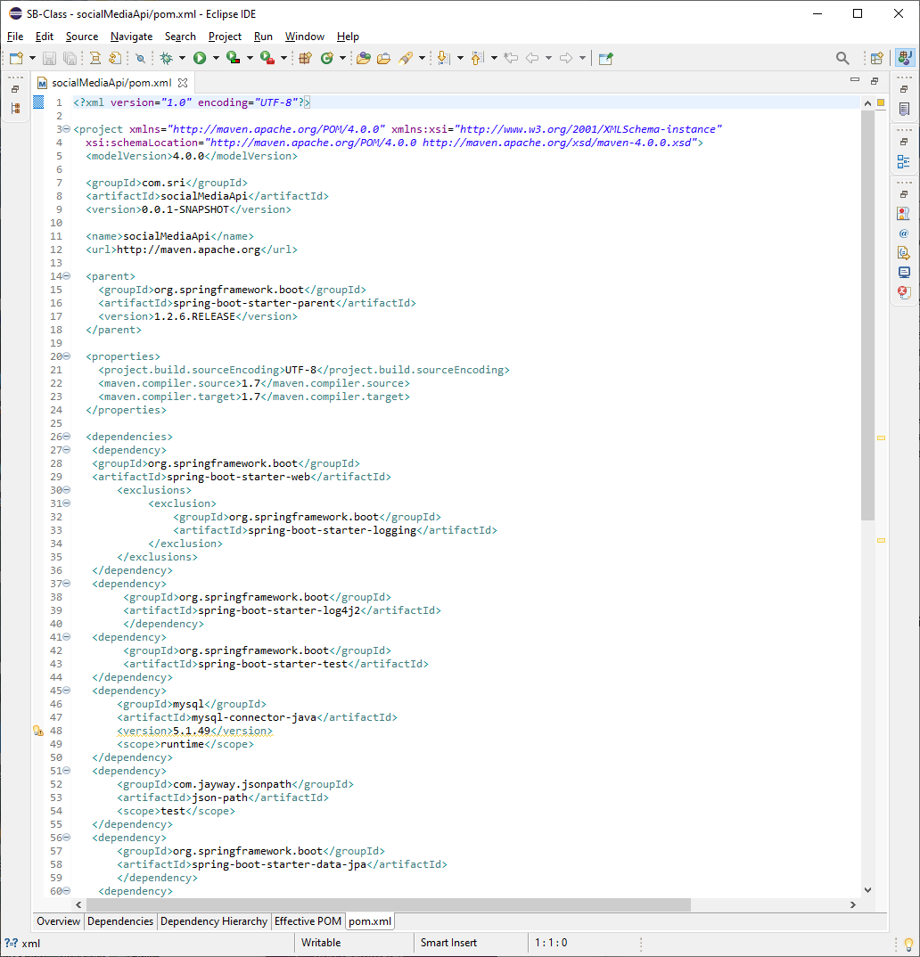

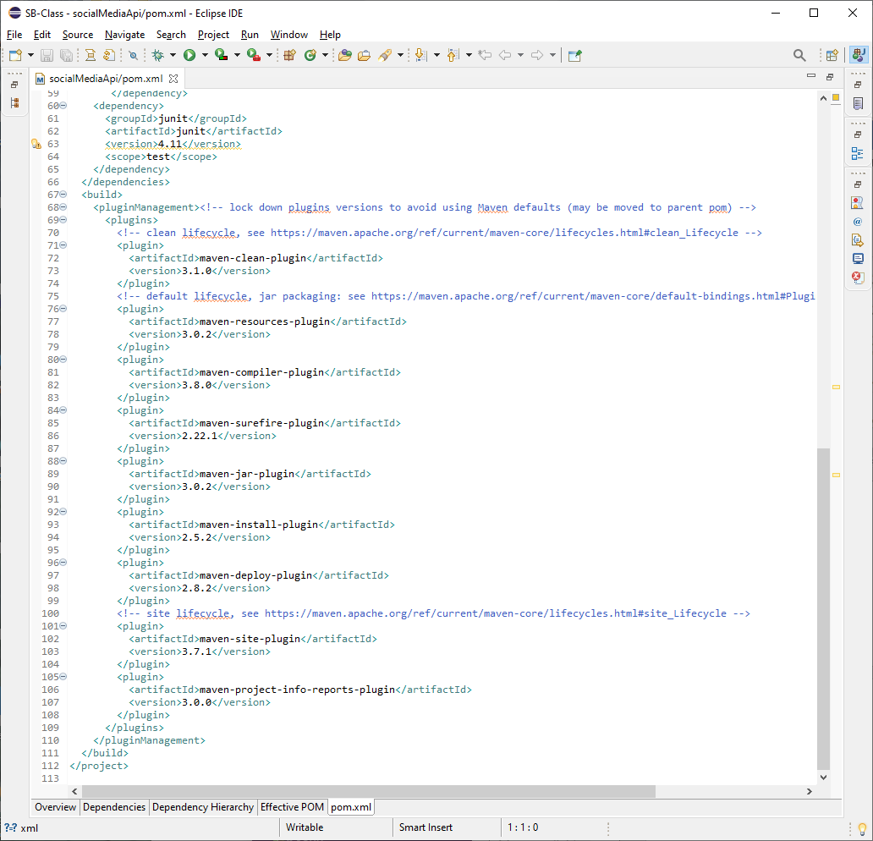

Project Folder Structure:

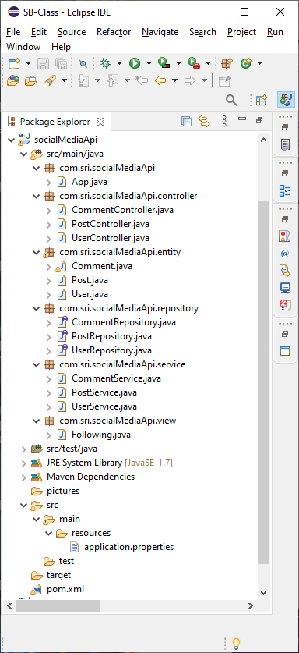

**Application.properties:**

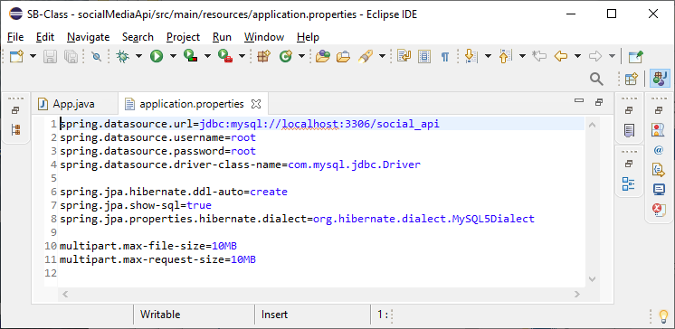

**App.java:**

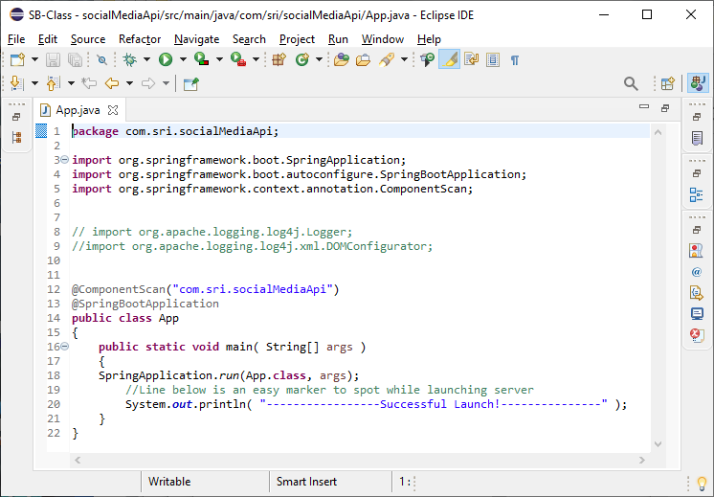

**Entity: Comment.java**

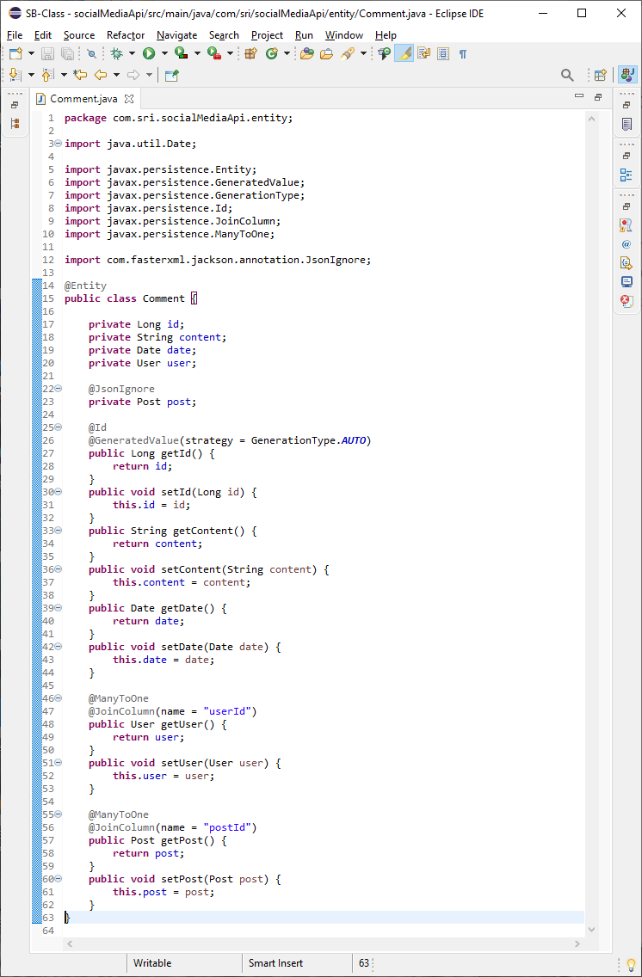

Entity: Post.java

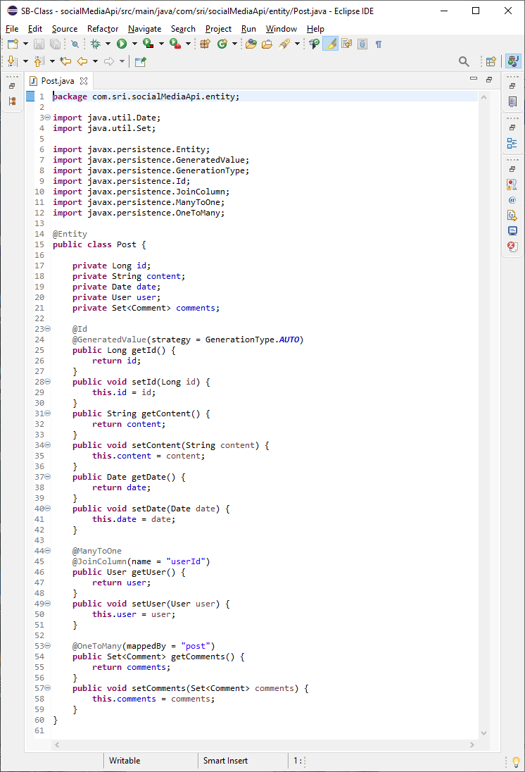

Entity: User.java

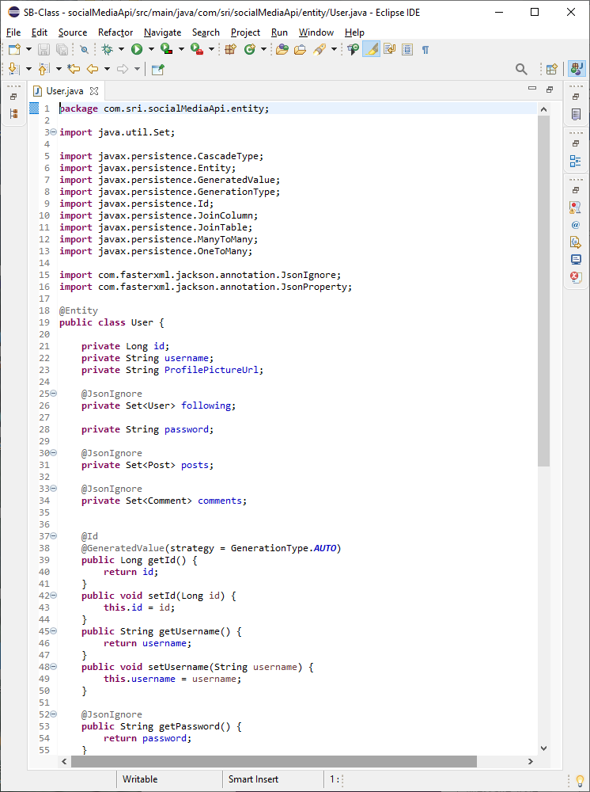

***Entity: User.java(continued)***

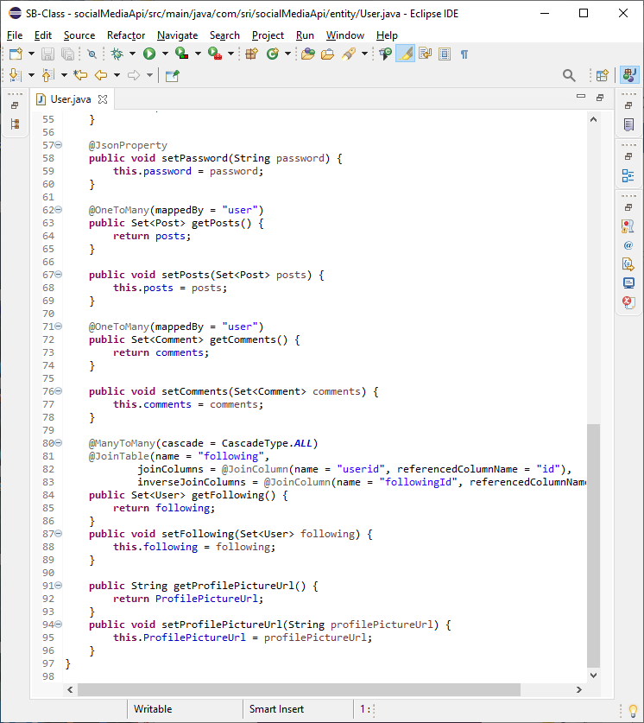

**Repository: CommentRepository.java**

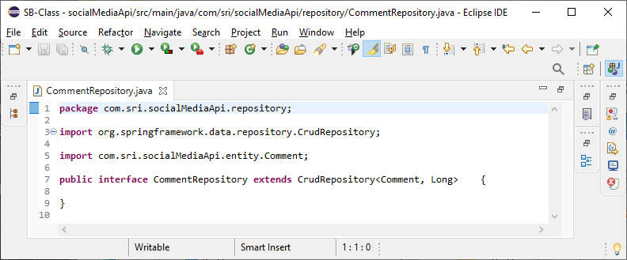

**Repository: PostRepository.java**

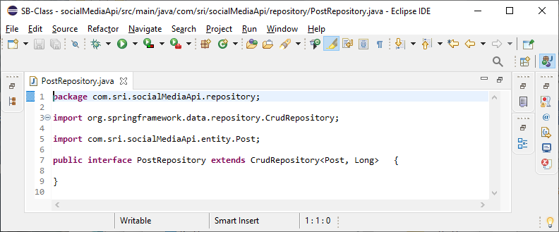

**Repository: UserRepository.java**

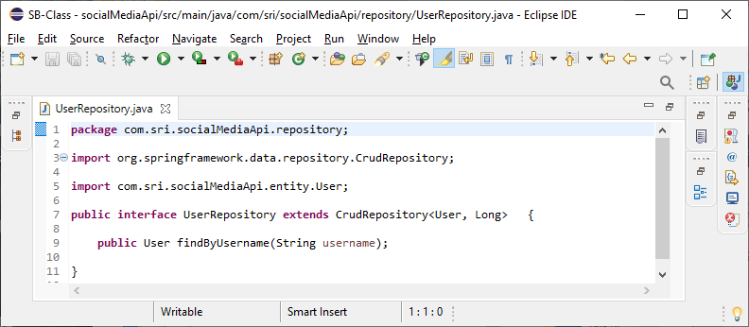

**Controller: CommentController.java:**

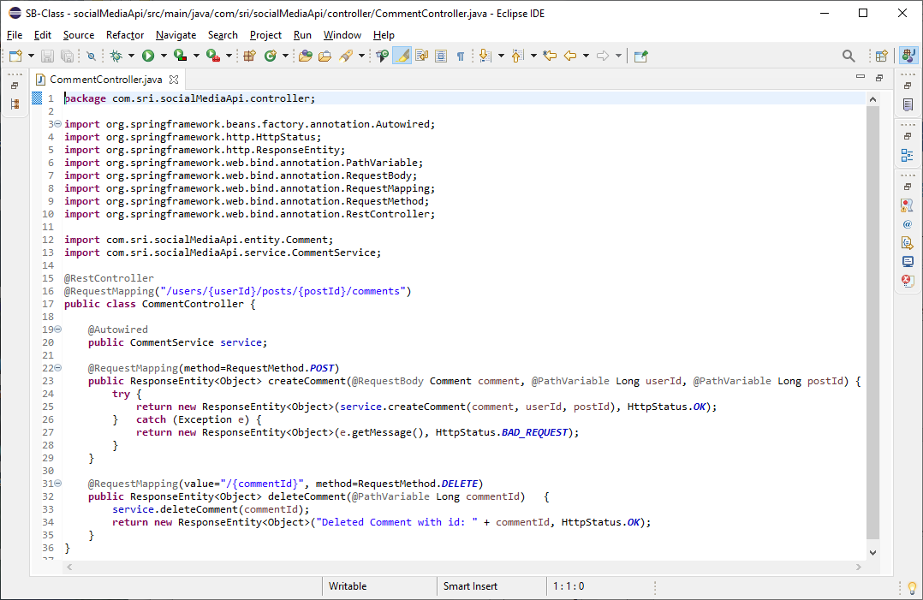

**Controller: PostController.java:**

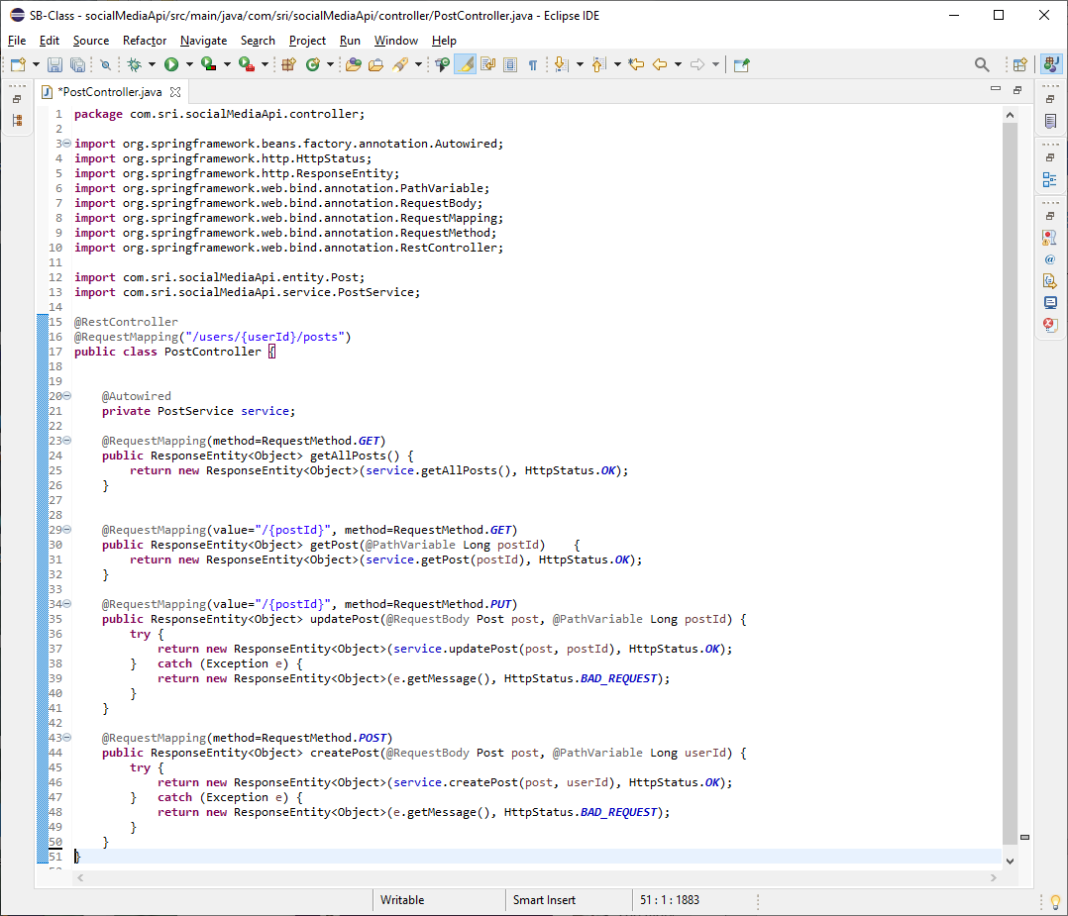

**Controller: UserController.java:**

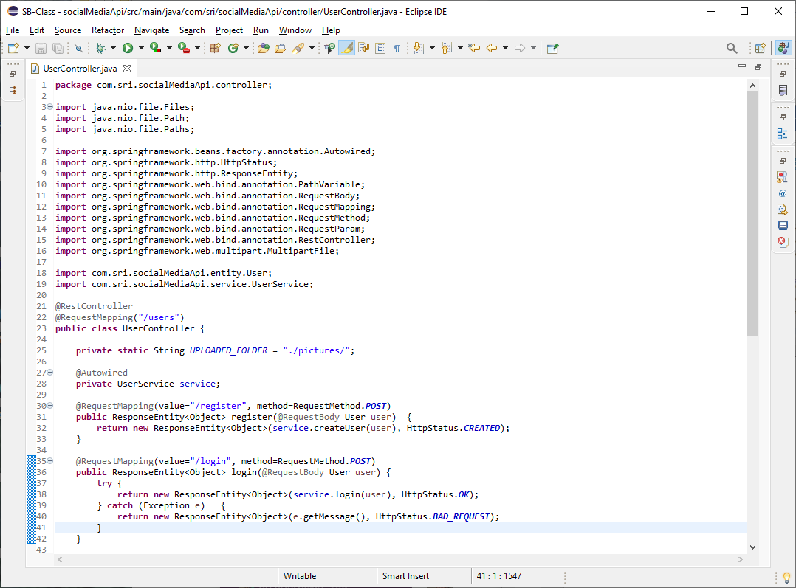

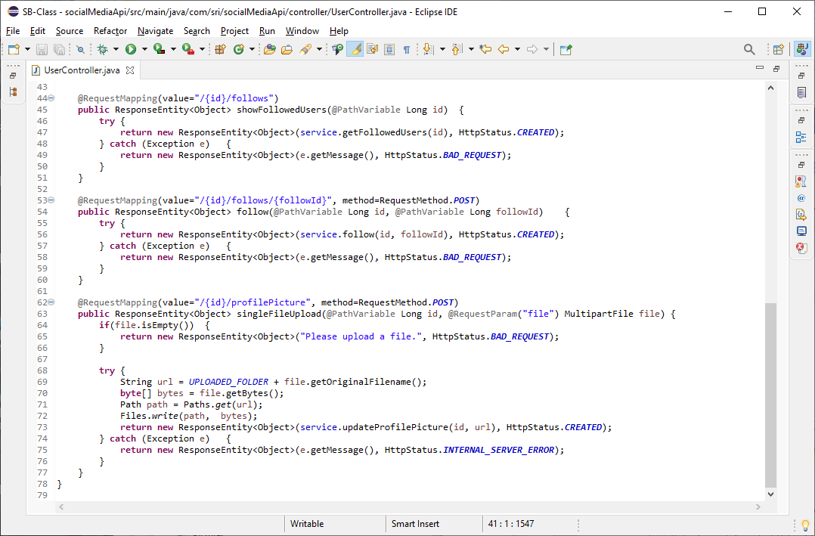

**Service: CommentService.java:**

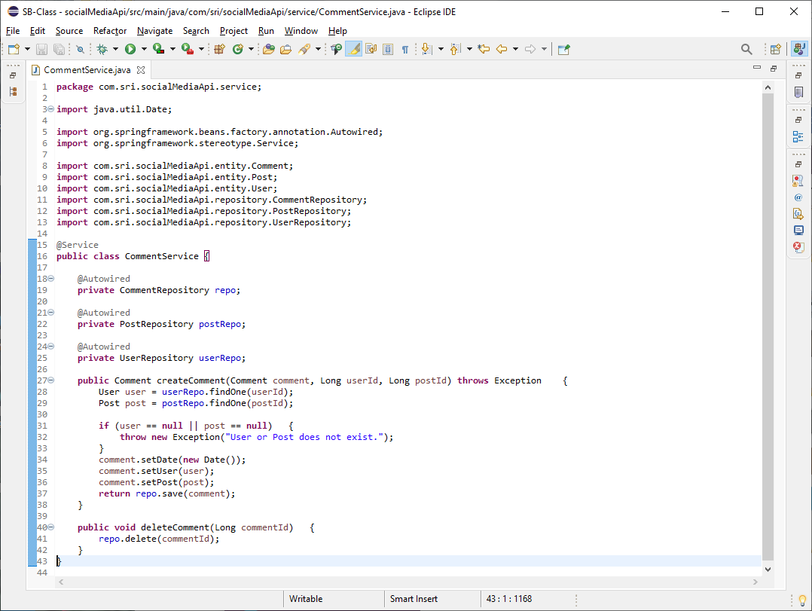

**Service: PostService.java:**

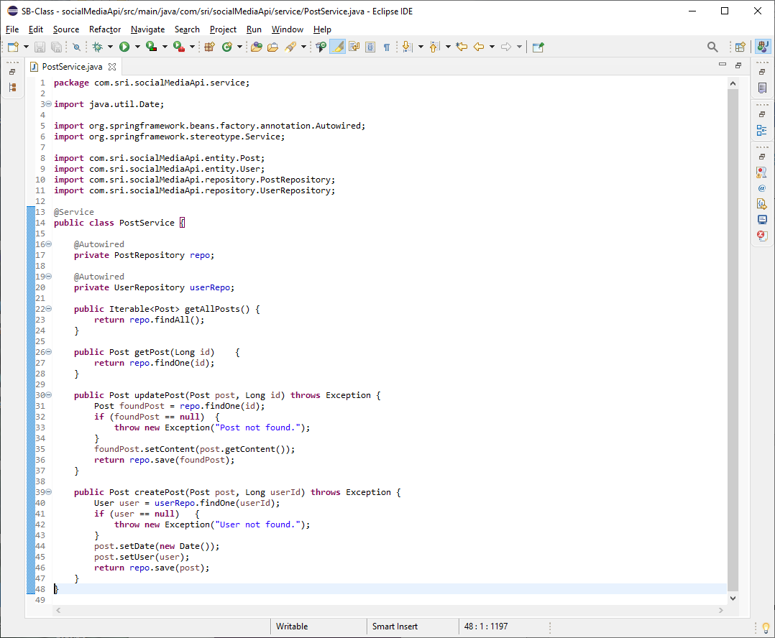

**Service: UserService.java:**

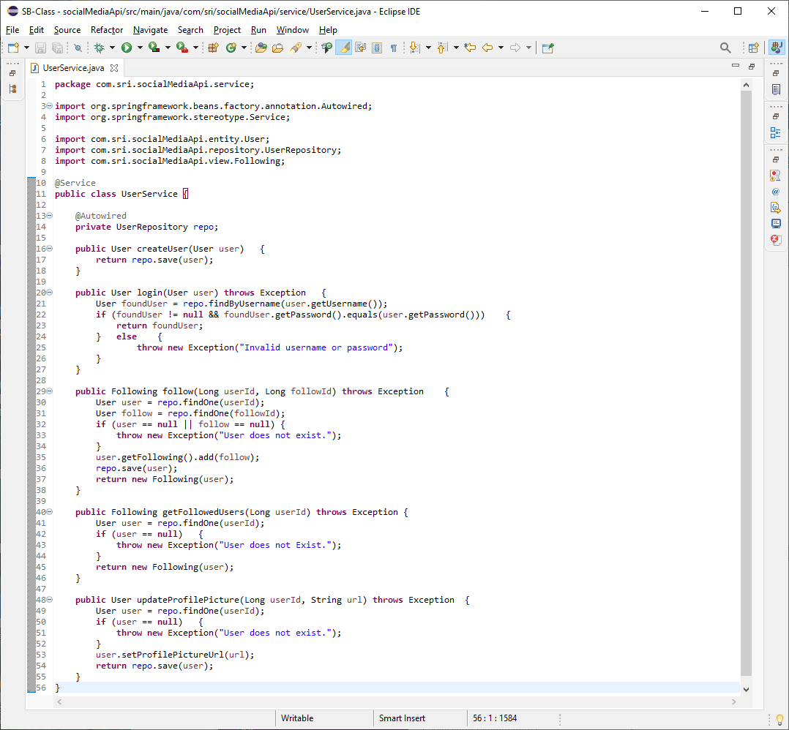

**View: Following.java:**

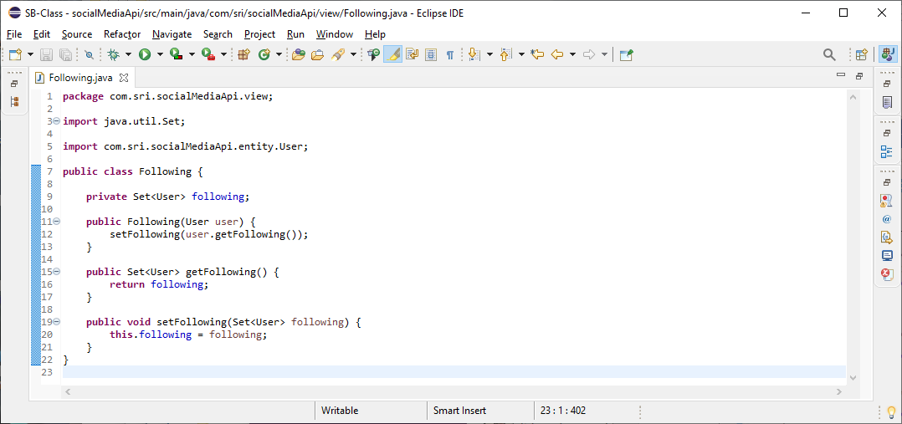

**Screenshots of Running Application:**

**Registering a user:**

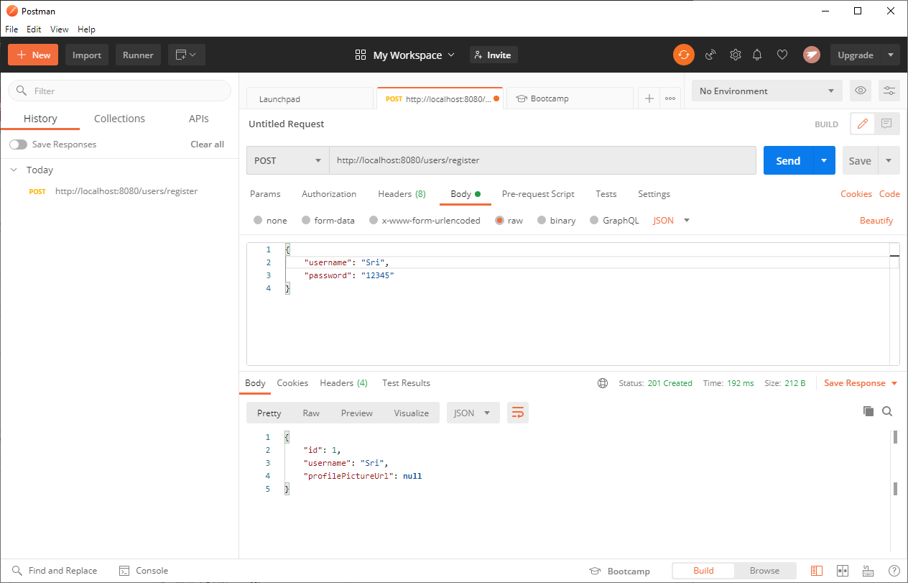

**Verifying the database entry:**

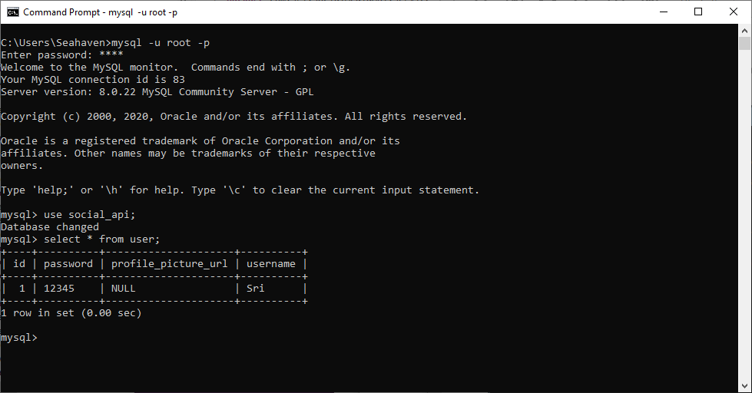

**Logging in as user:**

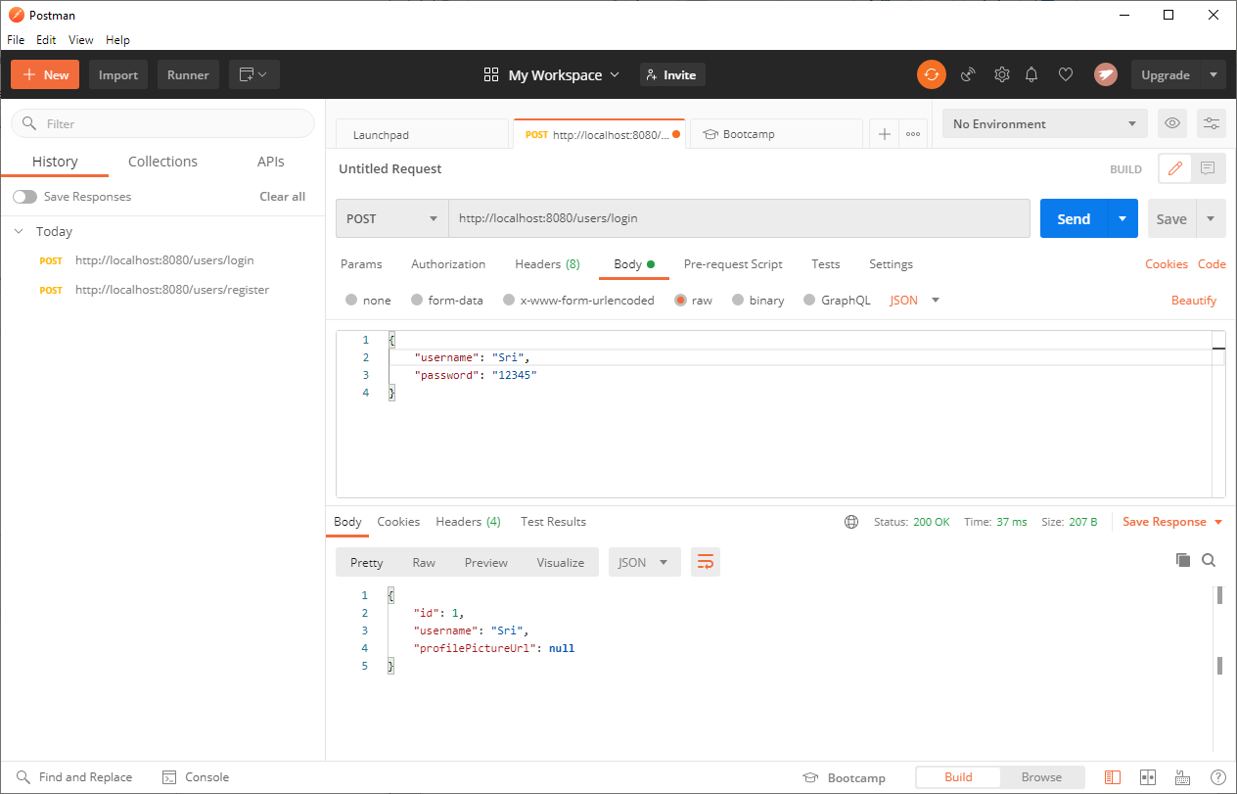

**Registering another user:**

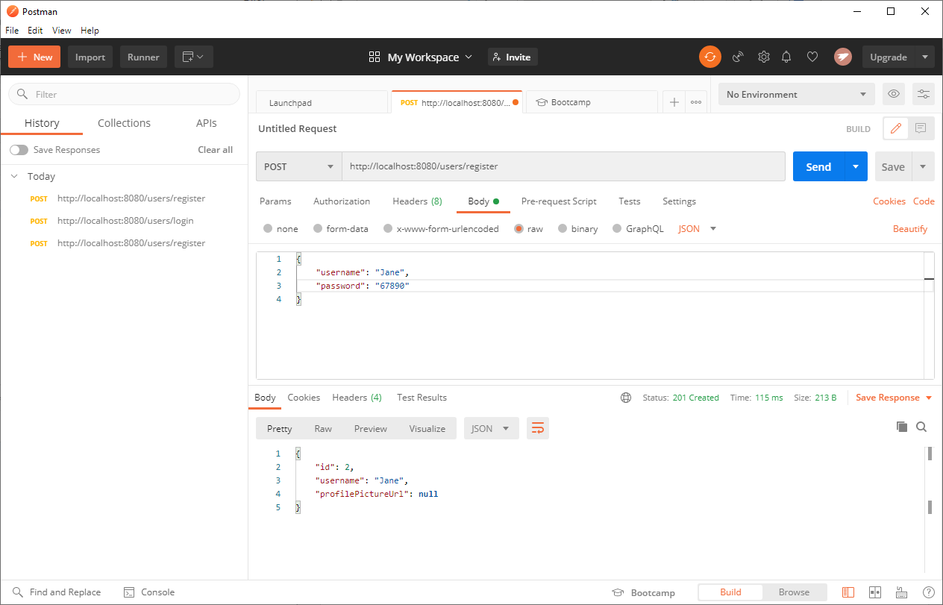

**Adding User 1 as Following User 2:**

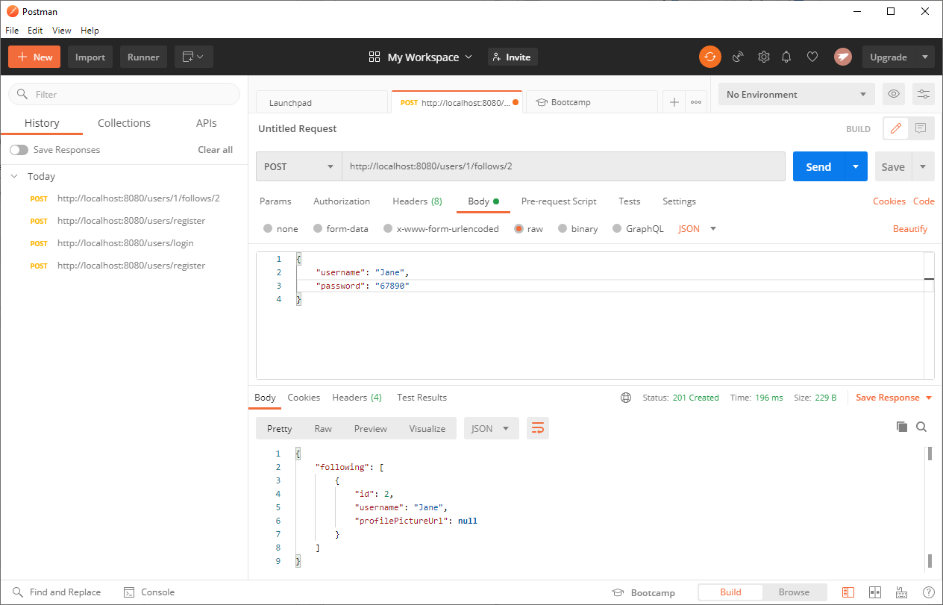

**Verify who User 1 is Following:**

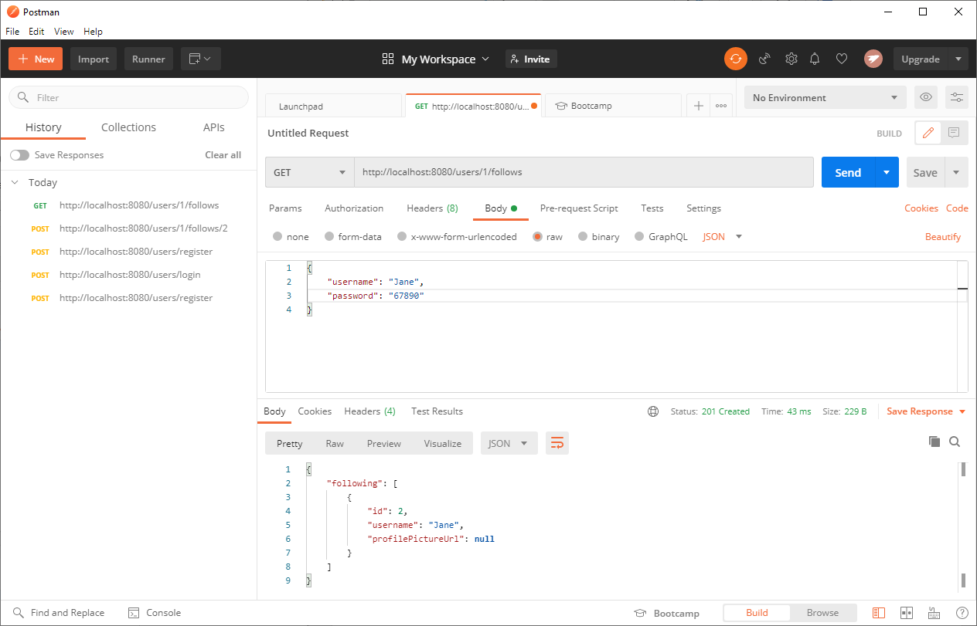

**Adding a Profile Picture for User 1:**

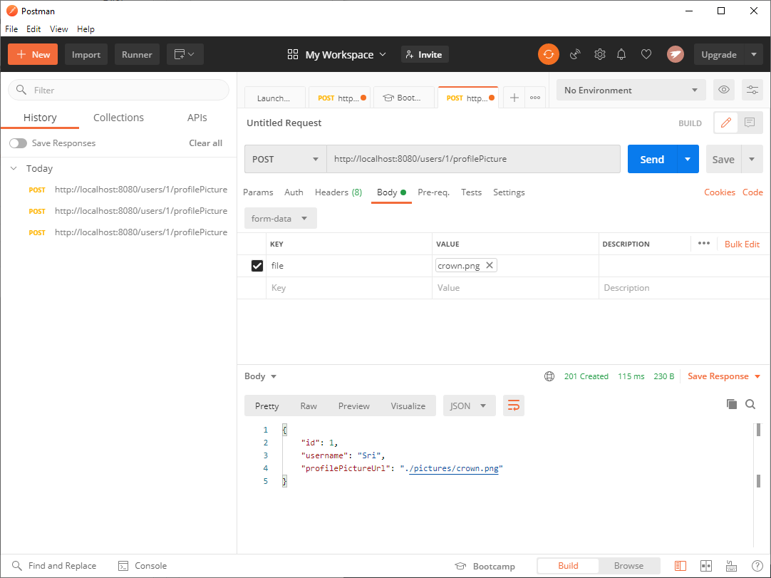

**Verification of profile picture in Eclipse:**

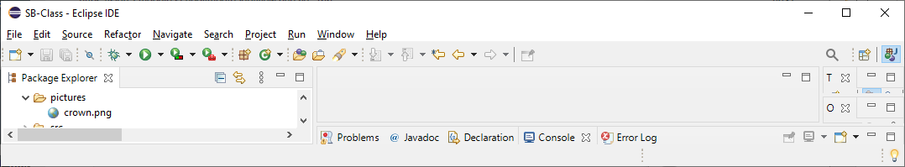

**Adding the first post for user 1:**

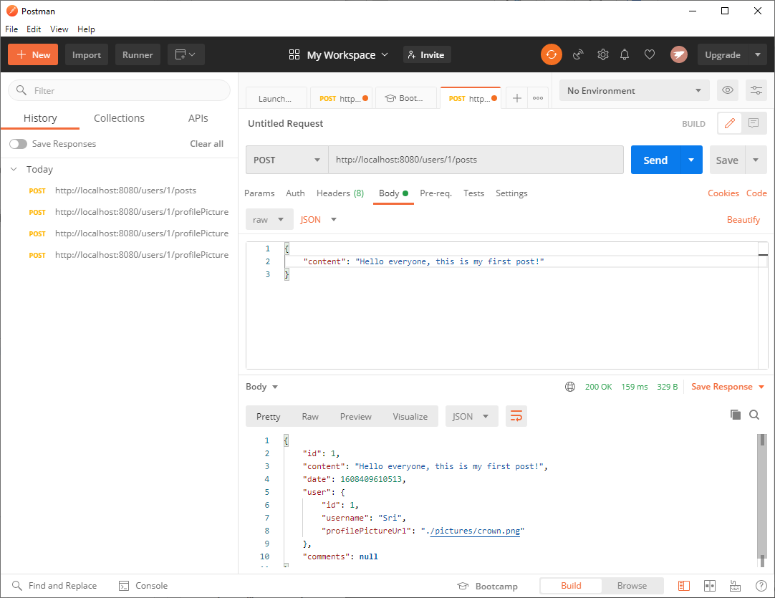

**Reading the first post of User 1 using GET in Postman:**

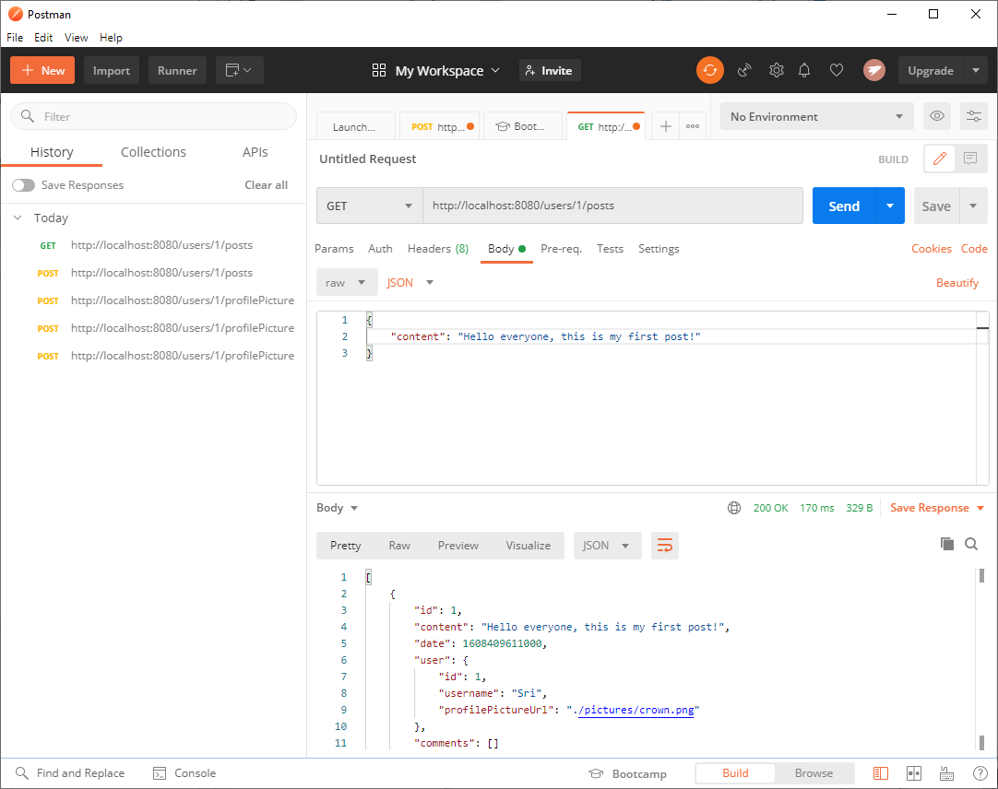

**Getting the first post of user 1 in Postman:**

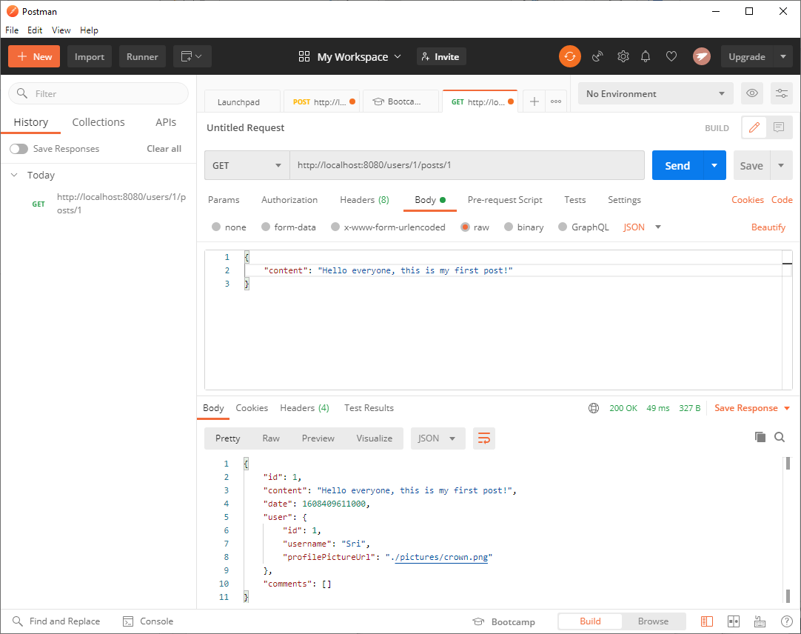

**Updating User1, Post 1:**

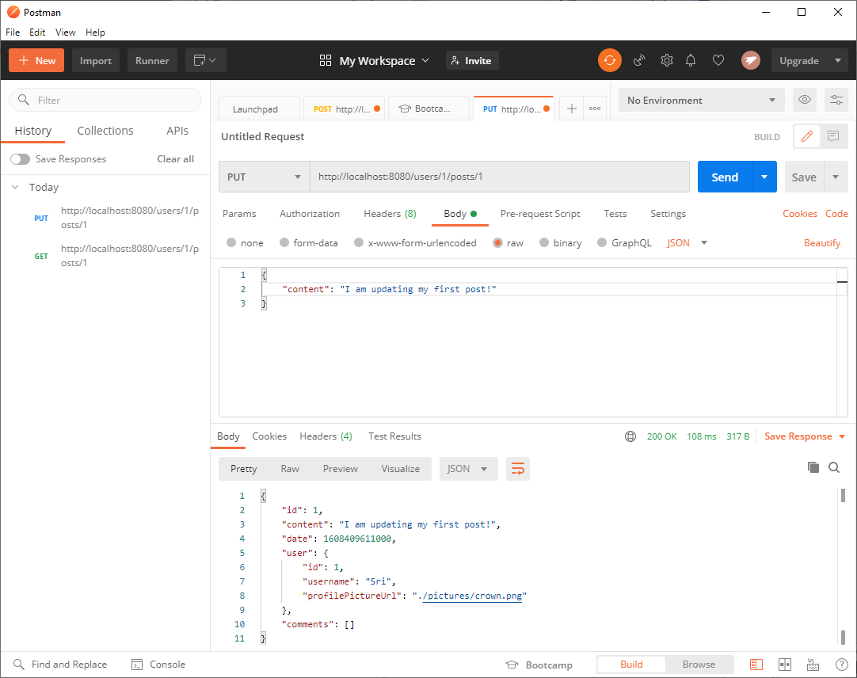

**Adding User2 Commenting on User 1 Post:**

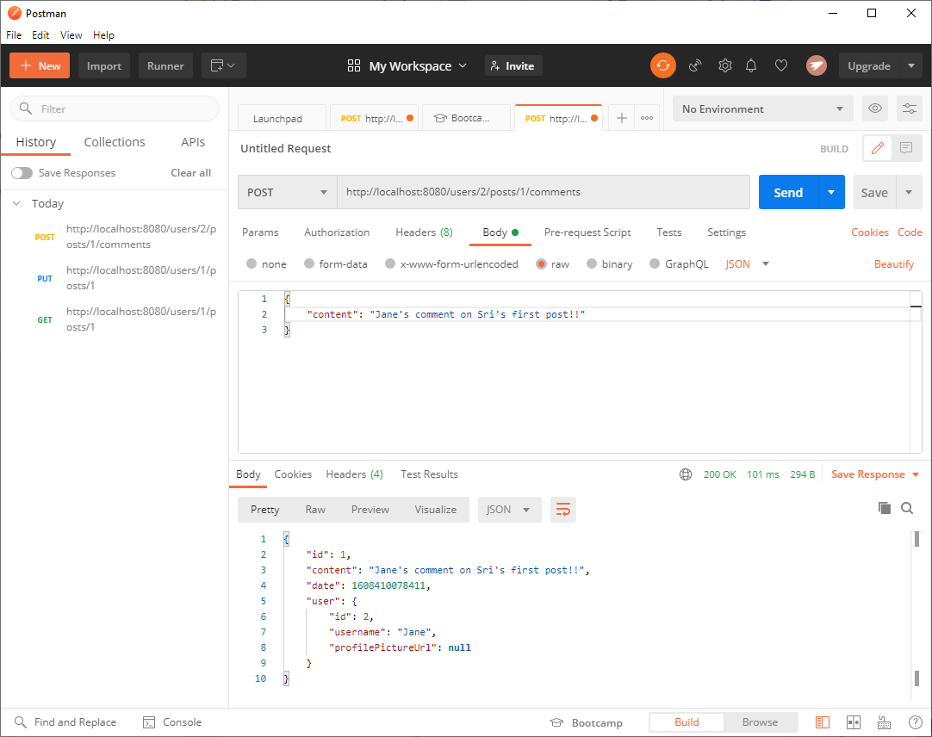

**Reading User 1 post with comments:**

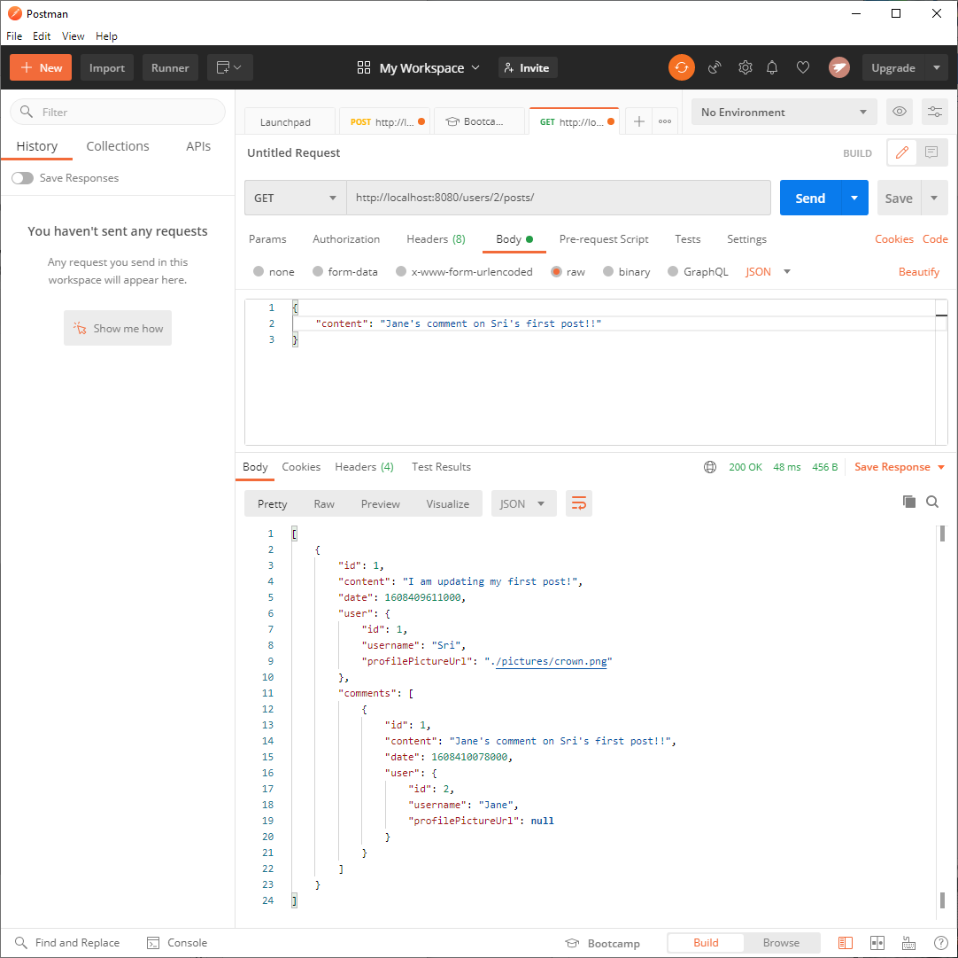

**Deleting the comment in User 1’s post:**

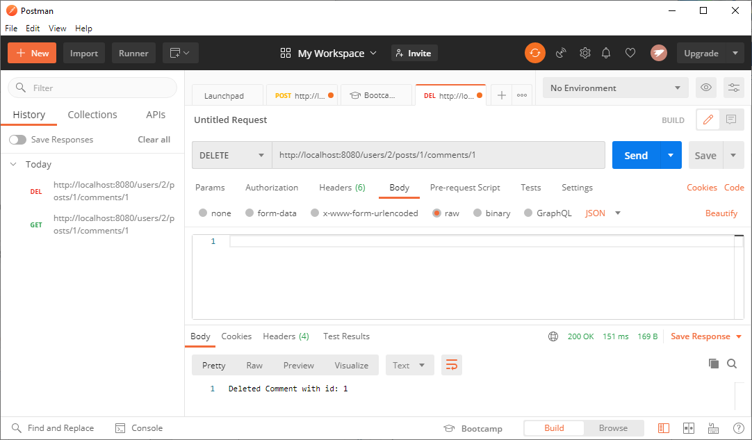

**Verifying Delete comments worked:**

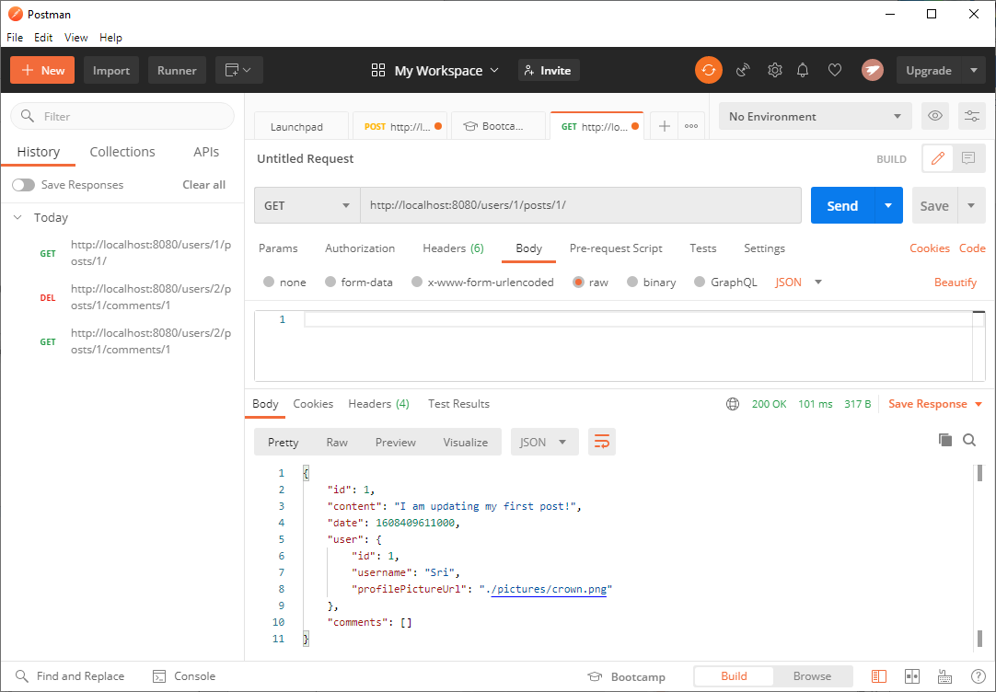

**THAT CONCLUDES THE SHOW AND TELL OF THE SOCIAL MEDIA API PROJECT!**

**URL to GitHub Repository:**

[**https://github.com/srikripa/SB-W1-Repository.git**](https://github.com/srikripa/SB-W1-Repository.git)